|  |  |
| --- | --- |
| Provided file(s): | * Lab07.docx * berkeley.xlsx |
| Submission file(s): | * Lab07.docx * Lab07.twb |

Work in your groups. Only one member of your group should submit. Only the last submission from before the deadline will be marked.

## Do Three-Part Tableau Mosaic Series

Do the following three-part series in Tableau on Mosaic Plots (this series calls them “Marimekko” charts, a synonym for Mosaic plots). You only need the first link below, as you can navigate to parts 2 and 3 from there, but I am including all three links for completeness. Take screenshots of all visualizations you create, and paste them below into the appropriate section with at least a one-sentence description/explanation each. Graphs should *not* look exactly like the examples given in the series. You must build the graphs yourself. The dataset is in the provided file, Berkeley.xlsx. Save all work to a Tableau workbook called Lab07.twb and submit it, when you are finished, along with this docx (Lab07.docx).

# Part 1: An introduction to Marimekko, a chart of many colors & names

<https://www.tableau.com/blog/introduction-marimekko-chart-many-colors-and-many-names-58111>

# Part 2: How to Build a Marimekko Chart in Tableau

<https://www.tableau.com/blog/how-build-marimekko-chart-tableau-58153>

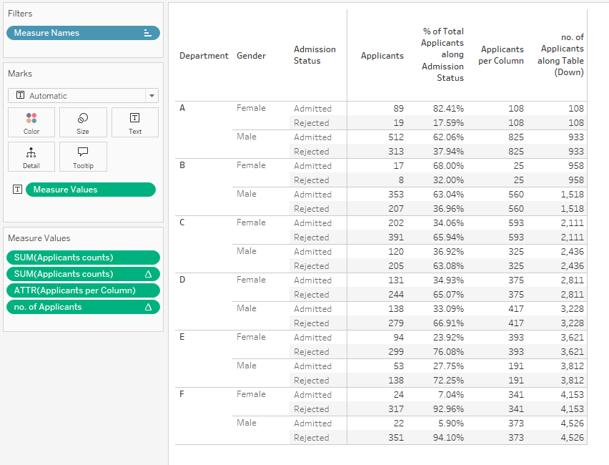

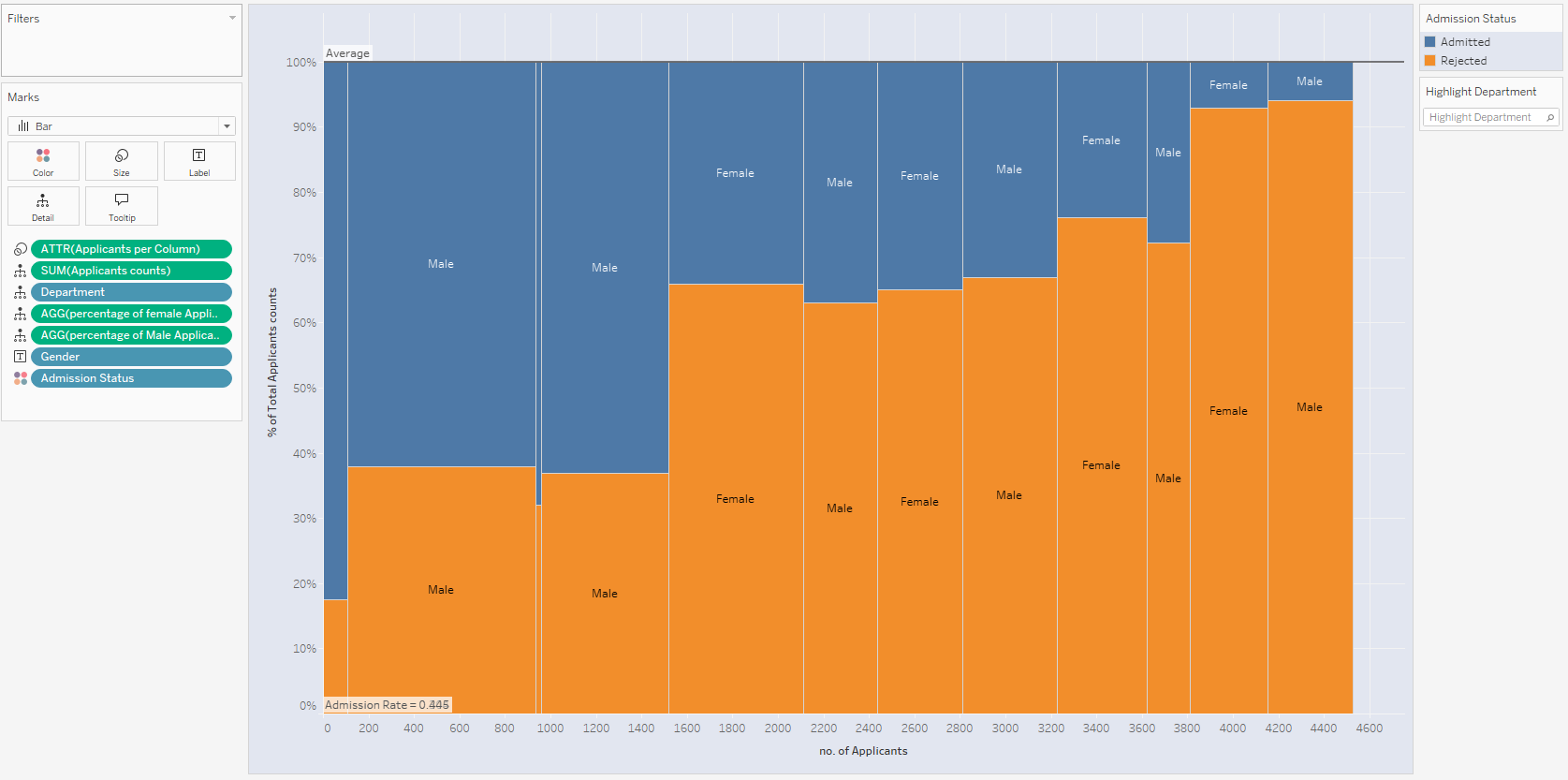

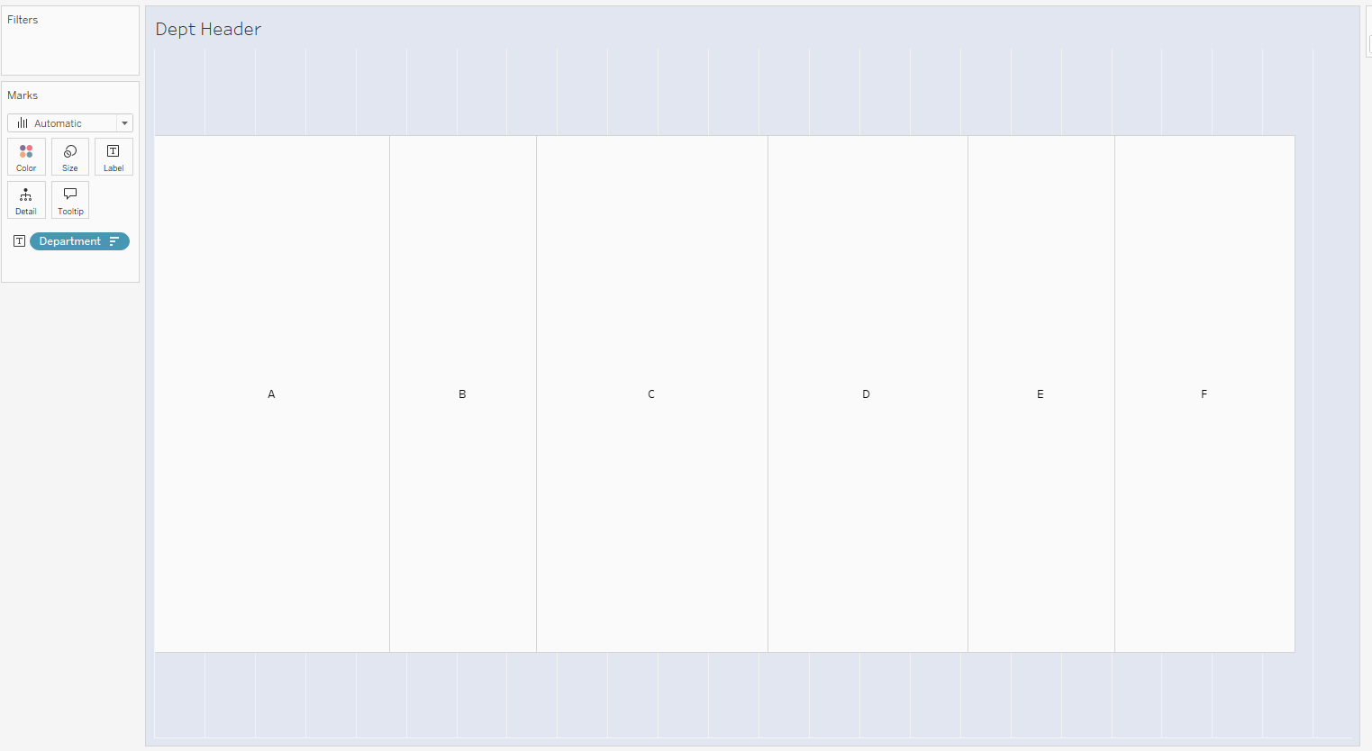

# Part 3: How to Add Context to Marimekko Charts in Tableau

<https://www.tableau.com/blog/how-add-context-marimekko-charts-tableau-58154>

